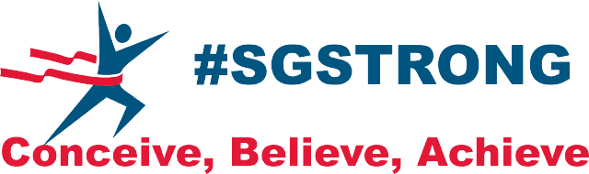

SPIN SPONSORSHIP FORM
MAY 19, 2019 @ 9:30 AM
SAG HARBOR GYM
$500 PER BIKE
Contact Name: __________________________________________________
Contact Email and Phone# _________________________________________
Mailing Address__________________________________________________
Name of Rider (if different from above) _______________________________
*Spin Sponsorship*
Individual or Team Sponsorship Name:________________________________
List Names of Team Members: _________________ _______________ _______________ ______________ _______________ _______________ _______________ ______________ _______________ _______________

*Drop off this form to Hampton Gym Corp in Southampton with payment or contact Stephanie Oakland at 631-484-9976 or Millie Fellingham at 516-316-1119 to make arrangements.

